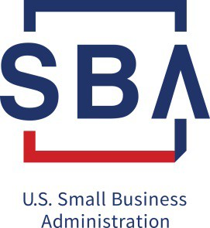
8(a) Offering Letter to Washington Metropolitan Area District Office

E-mail 8(a) Offering Letter to dcofferletters@sba.gov.
For a status update, please call our main office line at 202.205.8800
Please note: This is an interagency correspondence therefore the potential 8(a) firm should not be included.

The Offering Letter must include the following information:

- A description of the work to be performed;
- The estimated period of Performance;
- The NAICS Code that applies to the principal nature of the acquisition;
- The anticipated dollar value of the requirement, including options, if any;
- Any special restrictions or geographical limitations on the requirement;
- The location of the work to be performed for construction procurements;
- Any special capabilities or disciplines needed for contract performance;
- The type of contract to be awarded, such as firm fixed price, cost reimbursement, or time and materials;
- The acquisition history, if any, of the requirement;
- The names and addresses of any small business contractors which have performed on this requirement during the previous 24 months;
- A statement that prior to the offering no solicitation for the specific acquisition has been issued as a small business set-aside, or as a small disadvantaged business set-aside if applicable, and that no other public communication (such as a notice in the Commerce Business Daily/FBO) has been made showing the procuring activity’s clear intent to use any of these means of procurement;
- Identification of any specific participant that the procuring activity contracting officer nominates for award of a sole source 8(a) contract, if appropriate, including a brief justification for the nomination, such as one of the following:

  - The Participant, through its own efforts, marketed the requirement and caused it to be reserved for the 8(a) BD program; or
  - The acquisition is a follow-on or renewal contract and the nominated concern is the incumbent;
- Bonding requirements, if applicable;
- Identification of all Participants which have expressed an interest in being considered for the acquisition;
- Identification of all SBA field offices which have requested that the requirement be awarded through the 8(a) BD Program;
- A request, if appropriate, that a requirement whose estimated contract value is under the applicable competitive threshold be awarded as an 8(a) competitive contract; and
- Any other information that the procuring activity deems relevant or which SBA requests.

- Include a Statement of Work (SOW).

- Include contact person’s name, telephone, E-mail address, physical address, and FAX Number.

Please address the 8(a) Offering Letter to: Shuraie Mackin
Deputy District Director /8(a) Business Development Washington Metropolitan Area District Office
409 3rd Street, SW Second Floor Washington, DC 20416

